Annual Overview and Summary for Academy Programs 2018
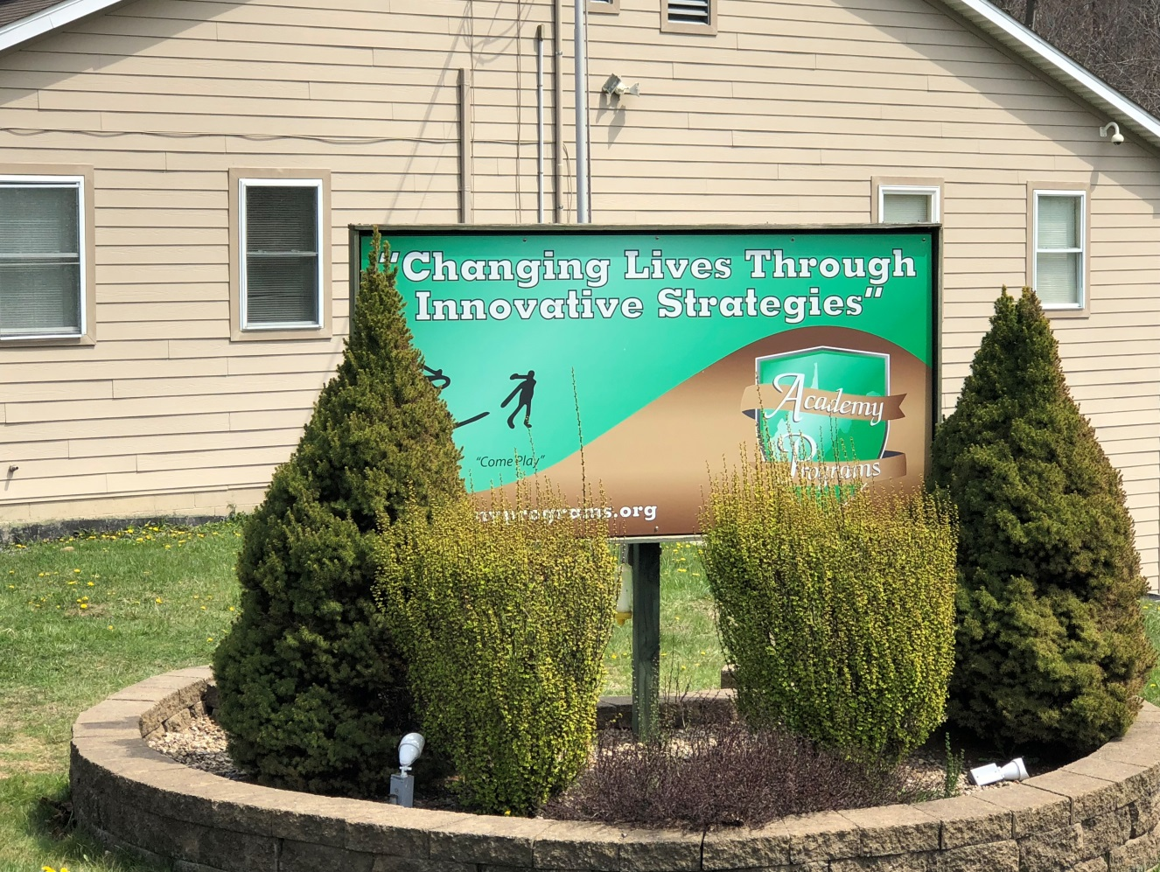
The “Come Play” graphic embossed on the sign for Academy Programs may seem to some to be out of place in an organization dedicated to the proposition of improving the adjustment of emotionally disturbed adolescents. Yet “Come Play” is more than a simple graphic; it is our creed for the innovative work we do, both for us, and the kids in our care. When we view our work as play, our challenges as opportunity, our struggles as a chance for victory, and our defeat as great learning experiences, we find ourselves immediately committed to a way of life with endless possibility. Such is the underlying philosophy of Academy Programs, how we approach our work with troubled kids, and how we wish to be perceived by our community.
The Academy continues to maintain its commitment to Re-ED Philosophy as the beacon for reaching children with emotional and behavioral disturbance. Re-ED is an intervention that combines psychological and educational strategies for working with troubled and emotionally disturbed children and adolescents. Re-ED Philosophy begins with two basic assumptions. First, that emotional disturbance is not something that a child or adolescent “has,” or not something in the person. It is not an illness, a disease, a disorder, or the by-product of pathology. Rather, Re-ED focuses on the presence of emotional discord as the result of a deficit in the child’s ecology. In short, they are a product of their environment. In order to change or modify behaviors that have prevented children from being successful in their natural environment, we believe that we must address and correct the shortcomings of that environment and give children the tools necessary to master successful living.
The second assumption of Re-ED Philosophy is the prescribed response to emotional disturbance by the treatment community. Traditional psychodynamic models of treatment rely heavily on individual and group therapy as a means of generating the insight necessary to promote behavioral change. However, in Re-ED, preference is given to experiential learning. We derive greater benefit from life as it is lived, as opposed to life as it is talked about during therapy sessions. Insight into the causal relationship of behavior and experiences is regarded as less important in generating behavior change as is actually experiencing the benefits of that change through successful and effective daily living. Success generates success and children who experience the benefits of living successfully on a daily basis gain the competence and confidence necessary to generate the desired behavior modification.
Education and academic competence are of equal importance in Re-ED as is an active involvement in traditional psychodynamic intervention. Research and experience demonstrate the crucial importance of academic competence in improving the adjustment of children. As such, Re-ED practitioners begin with an attempt to repair academic deficits as a means of creating a gateway to address and improve behavior, performance, and adjustment deficits. Children who perform with competence and confidence in the classroom setting are more apt to perform likewise outside of the classroom. For this cause, student performance in school is emphasized by all staff at the Academy.
In addition to maintaining our commitment to the practice of Re-ED and to improving the educational capacity of our student body, the Academy held firm in its traditional programming strategies. During Spring Break, our students found themselves engaged in a myriad of activity including Jurassic Safaris, rap battles, and re-making nostalgic movie musicals. The Sioux group claimed accolade with their remake of the Banana Boat Song from Beetlejuice. The Annual Battle of the Buildings contained daily group challenges with Yore Academy emerging victorious. The Man vs. Food event continues to be the crowd favorite with the Nine Layer Nachos being everyone’s favorite dish. While Youth Academy dominated the Cottage Decoration Competition with their Zombie Apocalypse Strong Hold, Yore Academy would claim victory due to outstanding academic performance on semester final exams.
In August, every group came together to construct a huge community campfire circle. After clearing the area of underbrush and debris, transporting construction materials from the parking lot to the site, and completing construction, campfire programming included storytelling, campfire songs, marshmallow roasts, and individual group skits. Halloween festivities continue to be a big hit with groups participating in cottage decoration contests and making short horror films.
The Academy continued to integrate athletic programming into our daily milieu as a means of challenging the physical capabilities of our students. Re-Ed holds fast to the notion that physical fitness and psychological fitness are both constructed within the same person. As such, improving psychological fitness, as well as physical fitness, results in enhanced effective functioning. We believe that our athletic programming helps us to meet these needs. Yore Academy demonstrated dominance during basketball season with Apache and Cheyenne claiming championships for the year. Spartans and Cheyenne would lay claim to the titles for both football and volleyball.
Our campus summer traditions continued with off-campus adventure. Groups from Academy Programs ventured away from campus in 2018 to visit Seneca Rocks for a three-day camping trip which included hiking and fishing. They visited the Pittsburgh Zoo, New River Gorge, Baltimore Aquarium, and the Carnegie Science Center. They attended Pittsburgh Pirate games and traveled to many local destinations for hiking, fishing, exploration, and learning. They attended sessions of the WV Legislature and were afforded the opportunity to speak with local delegates.
Our commitment to community service projects continued throughout the year with dramatic growth in the number of community causes adopted by the students at the Academy. In 2018, groups from the Academy would volunteer support for a wide range of community projects including Bartlett House, the Governor’s Adopt-A-Highway program, Marion County Humane Society, The Salvation Army, Union Mission, Taylor County Humane Society, Harrison County Humane Society, The Soup Opera, Ronald McDonald House, Marion County Parks & Recreation, and VA Hospital in Harrison County.
In addition to improving our internal and external community, the leadership at Academy Programs set out to dramatically improve the caliber of services offered to our student body in 2018. This initiative would address improvements in five different areas of Academy programming and services. First, The Academy launched an initiative to revamp and improve the Standard Operating Procedures in an effort to enhance fidelity and define “innovation in treatment”. Over 1000-man hours went into this six-month project with a heavy commitment in staff training and on-going supervision. Second, in an effort to decrease the average length of stay, Academy leadership developed improvements in our Graduating Academy Programs (GAP) protocols to target students who were experiencing difficulty advancing through the treatment process. As a result of these improvements to interventions, the number of students who fail to advance or progress in treatment has been shortened significantly. Next, the leadership set out to define and create new programming strategies that would enhance student investment and engagement in treatment programming. Although this project is currently on-going, initial efforts have been successful at redefining how we conduct weekly, monthly, and quarterly plans, as well as increased the amount of involvement students have in the planning process. Fourth, in conjunction with WVDE staff, the Academy developed program protocols for the “Bringing Education Alive” project. In this project, students are taking more field trips in conjunction with their studies in an effort to visualize what they are learning in their natural setting. Finally, we have laid the initial plans to improve and enhance staff recruiting, training, development, and retention as a means of building ‘depth on the bench.’
Nicholas Hobbs, the founder of Project Re-ED, noted that every person in the program must be responsible for inventing what Re-ED should become every day. He noted that Re-ED concepts, theory and philosophy must never exist as restraints on discovery nor invention. He noted that “should they become so, Re-ED will die, or worse yet, linger on simply because it is hard to do away with organizations, no matter how outmoded they may be.” (Hobbs, 1982, p. 31) The Academy roster is laden with people, young and old, who have committed themselves to the Re-ED tradition and the notion that young people can be helped though the process of re-education. This combined with our commitment to “Changing Life Through Innovative Strategies” allows Academy Programs to continue to provide the best possible caliber of service to our community and to kids in need.

The 2018 Academy Programs Annual Report will go into greater detail by addressing information in the following areas:
- Average Daily Census
- Occupancy Rate
- Total Number of Residents Served
- Permanency of Life Situation
- Graduating Academy Programs
- Average Length of Stay
- Academics
- Child and Adolescent Functional Assessment Scale
- Presenting Diagnosis and Success Rate
- Referrals
- Reportable Incidents/Safety Report-CIRT Review
- Safety Committee Report
- Satisfaction Surveys
- Staff Retention and Turnover
- General Staffing Patterns
- Smart Recovery
- Community Family Intensive Treatment (CFIT)
- Expenditures & Revenue

Daily Census and Occupancy Rate
Academy Programs provided services to 176 children in 2018, a 5% increase. The census rates for all three programs remained at or over capacity throughout the year. YALE Academy has served the most children, with Yore Academy a close second, as the need for substance abuse treatment for teens in West Virginia continues to be at an all-time high. Academy Programs continues to achieve a level of excellence regarding occupancy and serving children in need.
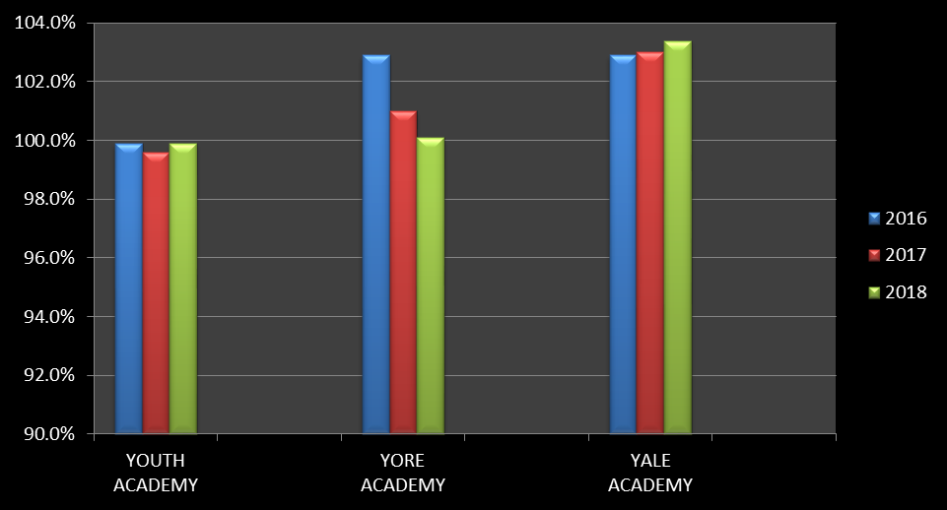

Individual program data:
2018 |  | TOTAL SERVED | POSSIBLE DAYS OF CARE 2018 | TOTAL DAYS OF CARE 2018 | AVG. DAILY CENSUS OCCUPANCY RATE
YOUTH ACADEMY | M | 27 | 8030 | 8019 | 99.9%
YOUTH ACADEMY | F | 25 | 8030 | 8019 | 99.9%
YORE ACADEMY | M | 42 | 8760 | 8765 | 100.1%
YORE ACADEMY | F | 18 | 8760 | 8765 | 100.1%
YALE ACADEMY | M | 49 | 8760 | 9058 | 103.4%
YALE ACADEMY | F | 15 | 8760 | 9058 | 103.4%

Permanency of Life
Academy Programs instituted outcome measures that stipulate 70% of all kids receiving services for 90 days or longer will be discharged to a home setting (foster home, birth family, adoptive, kinship care, lesser restrictive, or independence). Simply stated, permanency means family. It means having positive, healthy relationships with nurturing adults. In 2018, Academy Programs achieved 95% success rate in achieving a positive permanency of life for the children discharging from care. The Academy’s success is represented in the graph below:
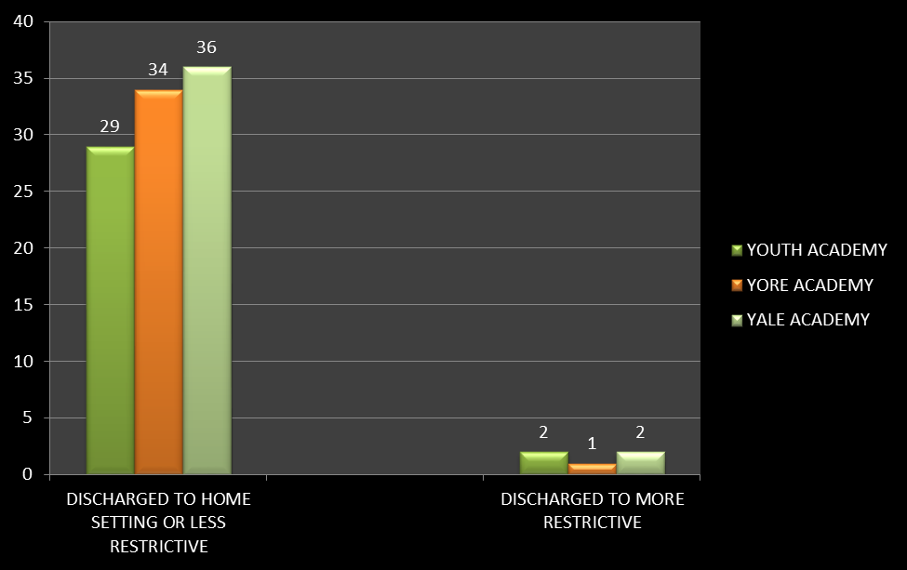
Per program data is represented below:
2018 |  | TOTAL SERVED | TOTAL DISCHARGES 2018 | DISCHARGED TO HOME SETTING OR LESS RESTRICTIVE | DISCHARGED TO MORE RESTRICTIVE
YOUTH ACADEMY |  | 52 | 31 | 29 | 2
YORE ACADEMY |  | 60 | 35 | 34 | 1
YALE ACADEMY |  | 64 | 38 | 36 | 2
 |  | 176 | 104 | 99 | 5

Successful discharges are also achieved through planning. Whenever possible, Academy Programs coordinates discharge planning with all of the members of the Multidisciplinary Treatment Team. Recommendations for further treatment services, school placement, and other supports necessary to help the student maintain the gains they achieved while with us, are provided to the team. At times, students are released at court prior to completion of the program and without benefit of the planning process. Although sometimes they are being released back into their parents’ care, it is without benefit of planned community services. At other times, students elope and remain at large, causing them to be released from the program. The information below is a representation of the planned and unplanned discharges for 2018:
2018 |  | TOTAL SERVED | TOTAL DISCHARGES 2018 | PLANNED DISCHARGES | UNPLANNED DISCHARGES | REASONS FOR UNPLANNED DISCHARGES
YOUTH ACADEMY |  | 52 | 31 | 28 | 3 | Runaway
YORE ACADEMY |  | 60 | 35 | 30 | 5 | Court or runaway
YALE ACADEMY |  | 64 | 38 | 35 | 3 | Court or runaway
 |  | 176 | 104 | 93 | 11

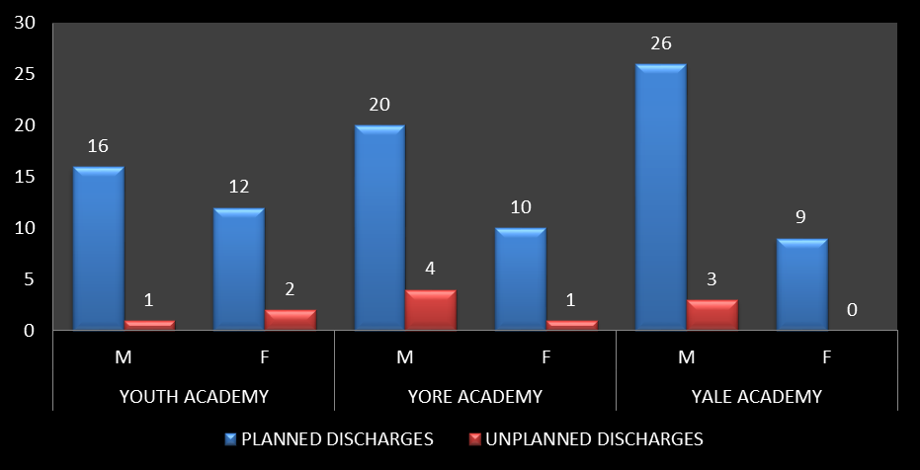

Graduating Academy Programs
A third measure of success is positively completing all phases of the treatment program and graduating with the skills and knowledge that will enable the students to return to their community successfully.

Academy Programs has developed and employs a six phase program known as Graduating Academy Programs, or GAP, delineating the steps a child must take in order to fully and successfully complete the program and utilize the strategies of this program as an integral part of the treatment planning process.

The program has three distinct components necessary for generating successful change in student behavior. First, students have the ability to influence their own destiny based on their involvement in the treatment process and the effort they independently choose to apply to modifying and/or changing the behaviors that have resulted in their removal from their homes, schools and communities. Second, Academy staff approach the implementation of this system in the vested interest of making students successful in obtaining the therapeutic milestones indicated, as opposed to holding them accountable to failure to progress the program in a pre-determined length of time. Finally, the program is comprehensive, combining all aspects of the students ecology including conduct in the residential setting (behavior points), successful completion of goals from their treatment plan, academic performance, substance abuse treatment and family involvement in the treatment process. This approach requires us to treat all sources of discord the student is experiencing, not just repeatedly address student behavior and absence of appropriate conduct.

The GAP program helps to generate investment in the treatment process by allowing students to identify exactly what is required in order to successfully complete the program. It allows professionals involved in the students’ treatment to see real-time data of the student progress in the program and to accurately answer queries related to the length of time required to complete the treatment process. It allows clinical staff to accurately gauge effectiveness of treatment planning as well as track the level of family participation, which is critical in the effective treatment of the student population. Also, the GAP program removes subjectivity based on professional judgement from the treatment equation. The effectiveness of interventions is easily visible and quantifiable while the need for additional interventions can be identified quickly.

Through the application of this program, Academy Programs is able to offer a consistent product to our referral sources as well as an effective treatment intervention for our student population. We are able to benchmark a child’s progress through the program and identify areas that a child must address and master in order to complete the program. The focus of the GAP program is completion of treatment milestones within the milieu and is specific to each child’s individual treatment needs. It allows children to gauge where they are in the treatment process and identify future challenges to complete the program. It also allows the parent(s), social worker, juvenile probation officer and judge to readily track a child’s progress through the program and allows us to objectively identify obstacles a child must overcome to successfully complete the program.

In our efforts to generate outcomes that are evidence based in accordance with our company values, we have developed and implemented this program in the treatment milieu.
Through the GAP program, students who achieve Bridge 5 or higher have achieved a measure of consistency in all areas of performance. They are internalizing the skills learned throughout treatment and are developing a success plan designed to help them overcome obstacles that prevented them from being successful prior to placement. Although graduates have the best success rate, students who discharge after attaining Bridge 5 are more likely to sustain positive gains. The percentage of students who graduated at Bridge 5 or above increased again this year. In 2018, discharges reflecting the GAP system are illustrated through the graph below:

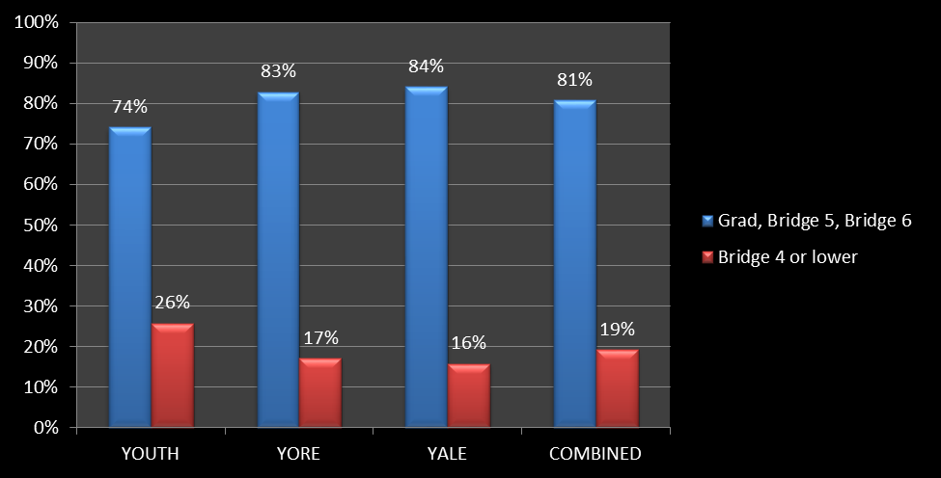
To further enhance success, if a child is unable to complete any bridge twice, she or he will take part in a small group designed to provide hurdle help in the area(s) that have caused them difficulty. The data below illustrates the positive improvement that has been shown through utilizing the GAP group.

 | 2017 |  |  |  |  | 2018
 | Youth | Yore | YALE | TOTAL |  | Youth | Yore | YALE | TOTAL
Bridge 1 | 3 | 4 | 0 | 7 |  | 2 | 2 | 0 | 4
Bridge 2 | 9 | 9 | 9 | 27 |  | 4 | 3 | 4 | 11
Bridge 3 | 9 | 3 | 5 | 17 |  | 11 | 5 | 8 | 24
Bridge 4 | 2 | 8 | 6 | 16 |  | 4 | 7 | 6 | 17
Bridge 5 | 1 | 3 | 0 | 4 |  | 0 | 2 | 2 | 4
Bridge 6 | 1 | 1 | 0 | 2 |  | 0 | 2 | 0 | 2
TOTAL | 25 | 28 | 20 | 73 |  | 21 | 21 | 20 | 62
% kids repeating a bridge | 49% | 48% | 34% | 44% |  | 40% | 35% | 31% | 35%

Length of Stay

“In planning Re-ED, we resolved to do everything possible to cut down the length of stay, to separate children from their families and schools (even for five days a week) only as long as we are clearly helping, and only up to the point where the system can operate in a reasonably satisfactory manner without our assistance. We feel that limited goals are sensible goals and that one must expand penuriously, and account honestly for, each day that a child is kept away from home, school, and community, from the normal arrangements for living in our society. We assume that there will be substantial individual differences in responsiveness of children and adolescents to the Re-ED program. Some may stay in a school a few days or weeks; others may require a number of months, even a year or so. But we have from the outset been determined to avoid the trap of assuming that some finite amount of time is required to let the therapeutic process occur. Experience has shown that our aspirations are soundly based. The average length of stay of a child in a Re-ED school today is from four to eight months, and the variability remains great, as it should.” (Nicholas Hobbs, 1982, pg. 259)

Length of Stay has been trending downward in most groups, with the exceptions being the females in the Youth Academy and the YALE Academy.
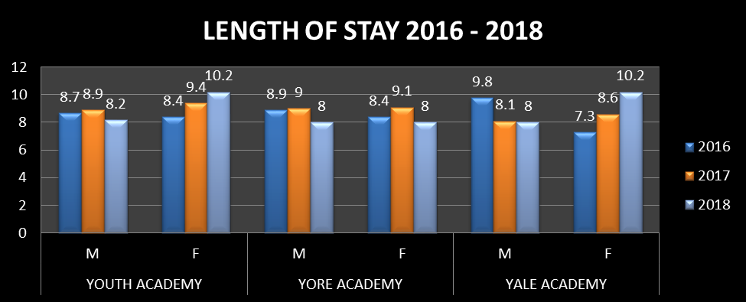
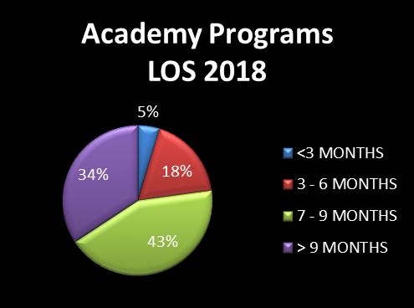
Academics
- Our school continues to be the highest academic performing school among all Office of Diversion and Transition Programs (ODTP) residential on-grounds schools since we completed our first year in 2008-2009.
  - 84% of all incoming students tested below grade level in Reading
    - While at Academy Programs, 79% of all students increased their Reading scores up to one grade level or more
  - 83% of all incoming students tested below grade level in Math
    - While at Academy Programs, 78% of all students increased their Math scores up to one grade level or more

- Offer 8 credits during the traditional school year
  - Five core subjects of PE, Math, English, Science, and Social Studies
  - Special Education and Options Pathways
  - Electives include but are not limited to Automotive Technology (Students are able to earn a National certification as a student ASE Certified Mechanics), Career Integrated Experiential Learning, Communications, Geography, Piano, Art, Music Appreciation, Health, Fitness, Computer Applications, Psychology, Sociology, Medical Terminology, Parenting, Child Development, Criminal Justice, Test Strategies, Journalism, Virtual School programming

- A full thematic based summer school is offered in which students can earn up to two credits toward high school graduation (the majority of public-school systems do not offer a summer school)

- All of our teachers are “Highly Qualified” under Federal guidelines

- Greater than a 1:1 student to computer ratio

- All student grades, transcripts, etc. are kept on the statewide public school computer system “WVEIS” (West Virginia Education Information System) which makes the transfer of student data for transition back to public schools immediate and seamless

- Federal “Title I” school which enables us to receive federal funding to run academic programs for at risk children.
  - Tutoring
    - 3 tutors, each working 3 days per week
    - Teachers hired to work on Saturdays for tutoring and Academic Remediation, Enrichment, and Acceleration (AREA)]
  - Full time Reading Intervention Specialist
  - Full time Transition Specialist providing discharge transition services for up to 12 months

- As a result of our Automotive Technology CTE program, we are now able to do the “Option Pathways,” which increases opportunities to earn a high school diploma through alternative methods

- Our Automotive Technology program has received commendations for the effective implementation of Simulated Workplace initiatives

- Students may be enrolled in distance learning classes:
  - “Credit Recovery” classes for students that have previously failed a class and need to retake that class for a credit
  - “Virtual School” for students that need a particular class that our school either can’t offer or that class won’t fit in our course offering schedule
  - College classes
  - Career Technical Education coursework

- Numerous other ODTP schools have toured our school due to directives from the superintendent as we are considered “the model school” for ODTP

- Implement a “Positive Behavior Support Program” called Reaching for the Stars, which recognizes academic excellence (3.25 in all eight classes for the week), appropriate behaviors, and perfect attendance.

- All students enrolled in our school have all academic performances analyzed through IDT reports (monthly), Reaching for the Stars reports (weekly), level reviews, academic recognition both monthly and quarterly

- Individualized instructional plans are developed for each student, regardless of whether they are special education or not. Instructional strategies have been commended by the WV Board of Education’s auditing agency, Office of Education Performance Audits

- Mandatory Comprehensive Semester Exams (all 8 classes each semester)

- Successful educational audits by:
  - Special Education
  - Federal Title I
  - WV Board of Education Administration
  - Simulated Workplace

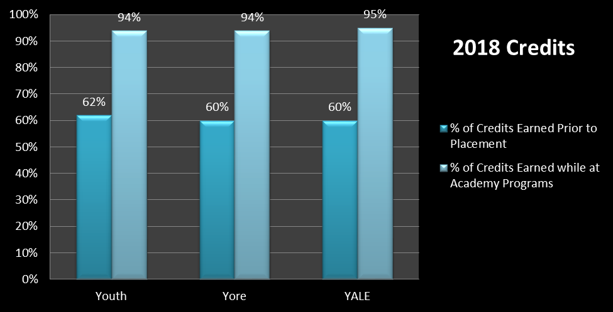
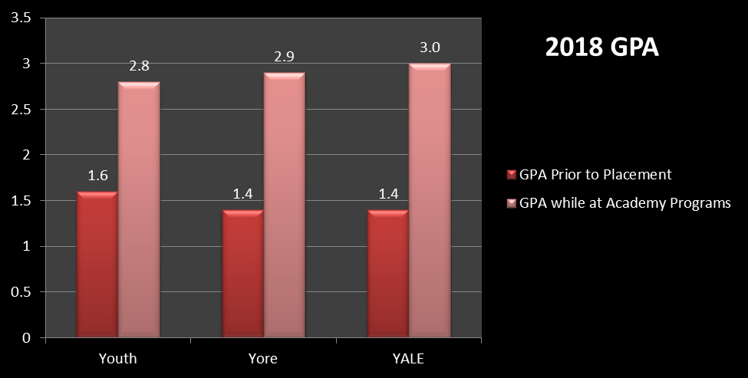
Legal Status
A status offense is a noncriminal act that is considered a law violation only because of a youth’s status as a minor. Typical status offenses include truancy, running away from home, violating curfew, underage use of alcohol, general incorrigibility or being beyond parental control. Status-offending behavior is often a sign of underlying personal, familial, community, and systemic issues, similar to the risk factors that underlie general offending. Sometimes these underlying issues contribute to delinquency later in life, putting youth at a higher risk for drug use, victimization, engagement in risky behavior, and overall increased potential for physical and mental health issues, including addiction.
Juvenile delinquents are minors, usually defined as being between the ages of 10 and 18, who have committed some act that violates the law. These acts aren't called “crimes” as they would be for adults. Rather, crimes committed by minors are called “delinquent acts.” They often include antisocial or criminal conduct. Delinquent acts may include crimes against persons, crimes against property, drug offenses, and crimes against public order. There are many factors that contribute to juvenile crime, including, but not limited to, poor education, low school attendance, peer pressure, disadvantaged socioeconomic status, and substance abuse. Juvenile delinquents are often confined to cells, without benefit of programming that would bring about change.
Academy Programs serves youth from both categories. We believe it is the most appropriate approach to provide treatment in a high-quality residential treatment program versus placing a kid behind bars in jail. In 2018, more delinquents were served in Yore Academy and YALE Academy, while there was an increase in status offenders in Youth Academy. The graph below illustrates our population in 2018:
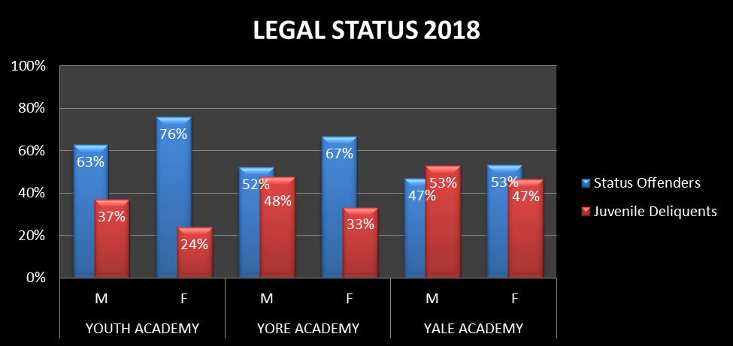
CAFAS
The Child and Adolescent Functional Assessment Scale (CAFAS) is used to measure functioning of children and adolescents in daily life activities. It was designed to assess youth with emotional, behavioral, psychological, or substance use problems. The CAFAS is currently being used in 30 states, typically to shape a child’s treatment plan, based on the deficiencies the youth is experiencing.
The CAFAS provides an objective, comprehensive assessment of a youth's needs that is sensitive to change over time, making it the most widely used outcome measure available.
Scores of 140 and higher indicate that the youth likely needs intensive treatment, the form of which would be shaped by the presence of risk factors and the resources available.
The CAFAS indicators that track change over time can identify youths who are not progressing well or who are functioning poorly even after some intervention. After identifying the types of cases that do not progress well, these cases can be monitored prospectively. The outcome indicators can be used to evaluate treatment protocols developed for specific student profiles.

As indicated in the chart below, students receiving services at Academy Programs consistently demonstrate a positive decrease in CAFAS score from intake to graduation. This trend indicates a consistent improvement in functioning and an increase in the ability to be successful in the student’s natural environment upon return to the community.

Presenting Diagnosis and Success Rate
As in years past, the overwhelming majority of youth being served have a presenting behavioral diagnosis in the largest category of Attention Deficit Disorder and Disruptive Behavior Disorder. These conditions involve problems with the self-control of emotions and behaviors.
Successful treatment of presenting diagnosis means that there was a decrease in symptoms and the youth were released to a less restrictive environment upon discharge. 95% of teens receiving services at Academy Programs were successfully returned home or to a home-like environment. In 2018, only 5% of the youths served were discharged to a more restrictive environment. Five of the 137 youth diagnosed with ADD/Disruptive Behaviors needed more intensive treatment and supervision.

Substance Abuse Diagnosis
The majority of students at Yore Academy and YALE Academy have a primary presenting substance abuse diagnosis of Cannabis Abuse. This is, in part, due to students’ attitude towards marijuana as being “socially acceptable” and non-addictive. There are fewer stigmas attached to marijuana use, so they freely discuss the extent of their use. Students typically admit to using a variety of other drugs; however, they tend to minimize the frequency, intensity, and duration of that use, therefore not meeting the criteria for diagnosis. After they begin to feel more comfortable in the program, students open up about their true substance use history.

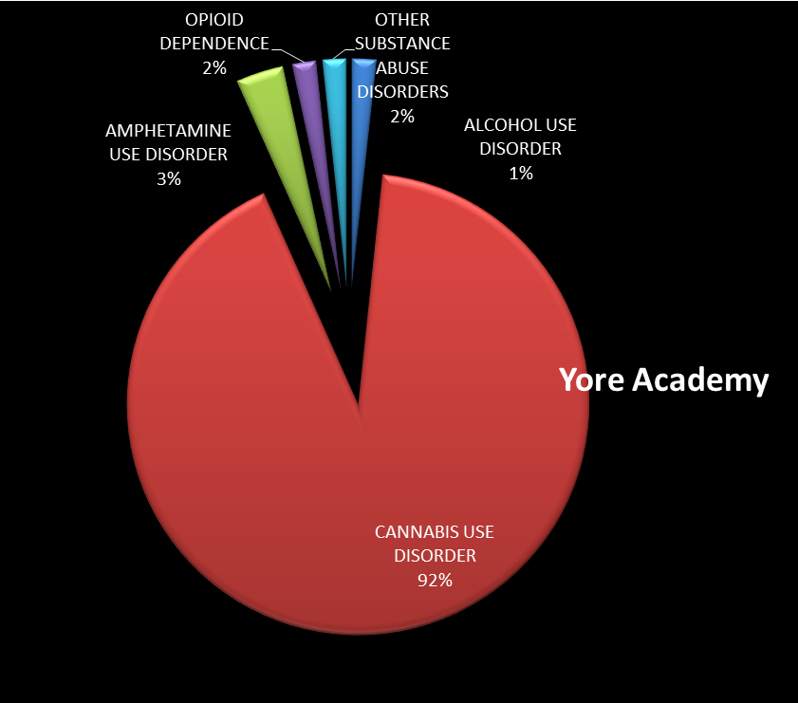
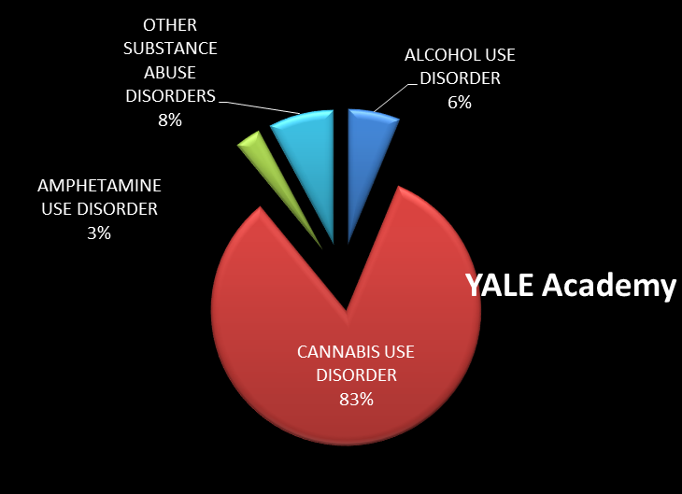

Although the Youth Academy is designed to treat children exhibiting behavioral and/or emotional issues that prevent them from being maintained in their homes, they often have substance abuse diagnoses and/or substance abuse issues at admission, or that are uncovered in the course of treatment. These substance abuse issues are addressed throughout their treatment, in the same way as those dually diagnosed residents of Yore and YALE Academy. As shown below, the prevalent substance abuse disorder in 2018 was Cannabis Use Disorder.

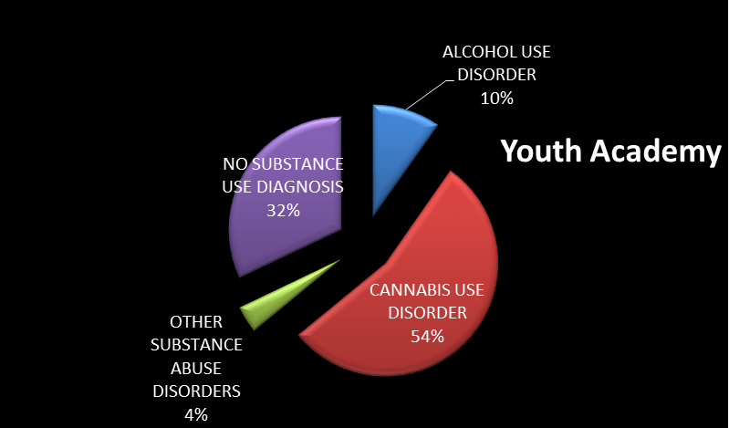

SMART Recovery
SMART, stands for, Self-Management and Recovery Training. This is a self-empowering addiction recovery group which focuses on assisting participants in learning a variety of tools for recovery. The program is based on scientific research, more specifically, the REBT (Rational Emotive Behavior Therapy) Model, which is a form of psychotherapy. SMART differs from Alcoholics Anonymous, Narcotics Anonymous, and other 12-step programs. SMART teaches self-empowerment and self-reliance. It provides meetings that are educational, supportive and include open discussions. In addition to substance abuse recovery, it addresses positive choice making for all students. Individuals are taught techniques for self-directed change.
Individuals concentrate on their own desire to make better choices, focusing on recovery in lieu of a moderation approach. At Academy Programs, all youth participate in SMART Recovery from entry to graduation. The youth’s progression through SMART is dependent on self-management. Youth are prepared to transition into an online meeting after discharge, therefore offering them an even greater chance of success.
Referrals

Referrals are received from all over the state. Each program has remained at capacity (or over capacity) for the year. Yore Academy and YALE Academy have been ordered over capacity in order to accommodate the immediate need for substance abuse treatment. The majority of referrals in the past few years were received from Regions II and III.

Youth Academy Yore & YALE Academy
Referral Totals by Region Referral Totals by Region
Region I 121 Region I 85
Region II 202 Region II 153
Region III 127 Region III 89
Region IV 86 Region IV 61
TOTAL 536 TOTAL 388
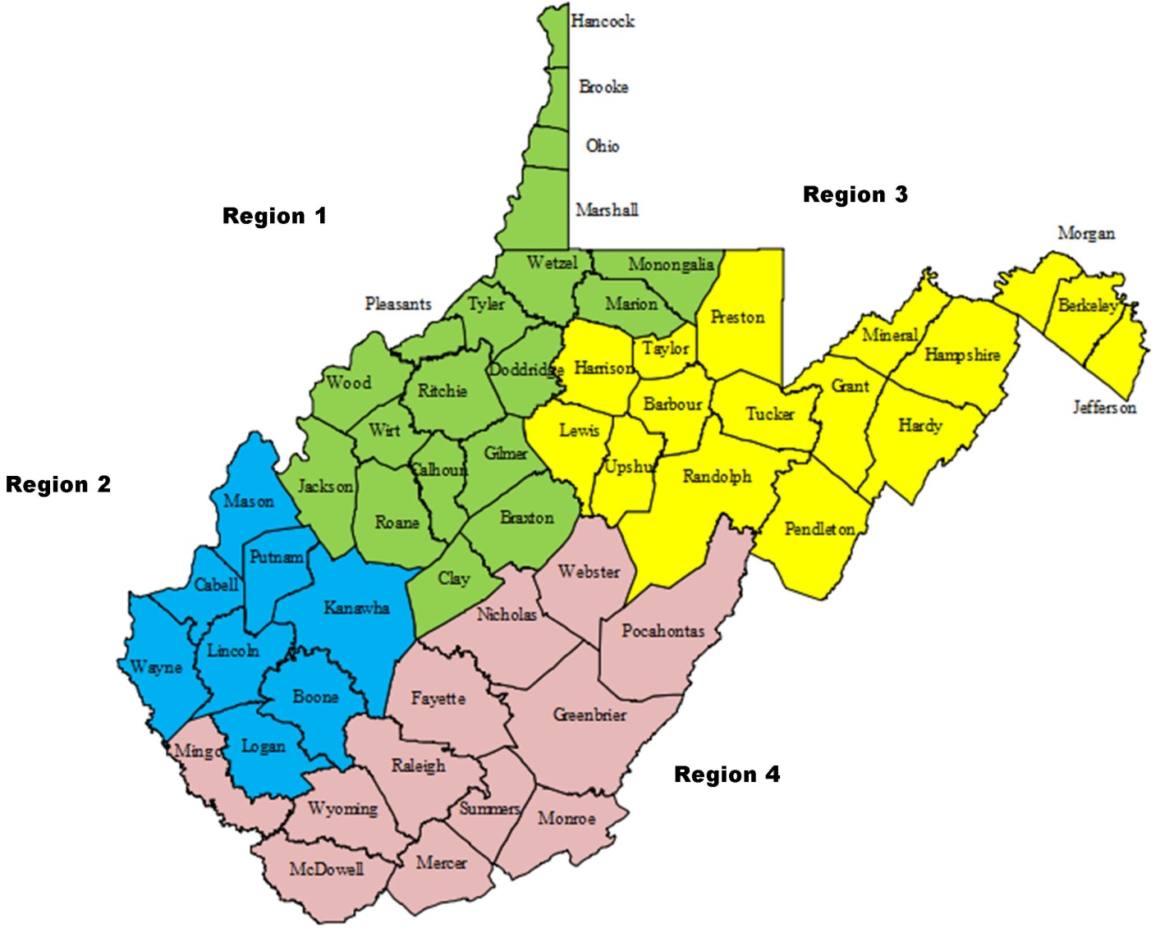

Referrals Not Served
Academy Programs is not able to serve all the children that are referred for treatment. A total of 924 referrals were received, while 748 had to seek treatment elsewhere.

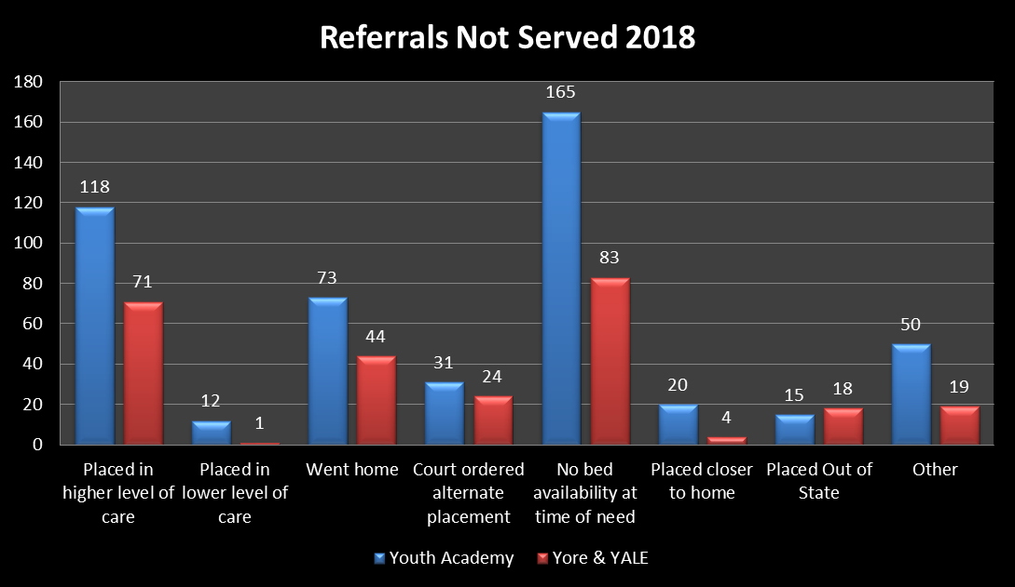
Referrals Served
Academy Programs served 176 youth from 31 different counties in West Virginia. The majority of students were served from Kanawha (38), Cabell (27), Harrison (26), Randolph (10) and Preston (9) counties.

Critical Incident Review Team (CIRT)

The CIRT is charged with reviewing and identifying trends within the critical incident process and to identify programmatic issues needing addressed. It is important to note that a single behavioral occurrence can result in multiple incidents (i.e. two students in an altercation may result in incidents of physical aggression, verbal threats, and a physical intervention). The average number of incidents per day in each program is low. Client injury is overwhelmingly a minor injury as a result of a sports or social activity/game.

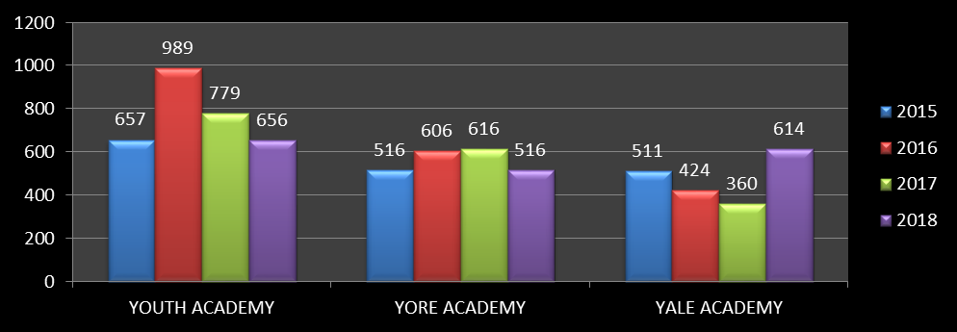

Safety Committee Year End Report 2018

Monthly Walk Through Report:
The walk-through reports for 2018 addressed minor maintenance and repair issues due to damage caused by students. Cottage cleanliness was also monitored closely. Plans of action again focused on specific groups and areas that needed attention. No trends or patterns were noted. Program Directors and Team Leaders inspect cottages daily.
Fire Drill Report:
Monthly review of fire drill records indicate that fire drills occurred in appropriate time frames and were completed successfully. Drills were completed at different times of the day to include all staff.
Outdoor Programming/Safety & Supervision:
Outdoor experiences provide diversity in programming. Group processes outside the home, cottage or classroom challenges individuals and the group to expand their interactive and social skills to a higher level. Staff must be aware that outdoor experiences may initiate “actual and perceived risks” for various youth or groups that must be managed therapeutically and educationally. Several groups left campus for day trips to points of interest in West Virginia and beyond.
CIRT Report:
Critical and noncritical incidents are monitored closely. Physical aggression in the Yore Academy and Youth Academy decreased in 2018, while YALE Academy showed an increase. De-escalation techniques were utilized to reduce physical confrontation. Physical Intervention was used to keep students safe. Medication errors decreased over the year. Medication refusals were investigated and found to be behaviorally related. All suicide threats/ideations are immediately referred to the Director of Treatment for assessment and plan of action. Substance Abuse numbers include incidents of nicotine usage as well as narcotics.
Grievances:
All student grievances were addressed and resolved successfully.
Satisfaction Surveys 2018
Satisfaction surveys were completed by the residents in each program. Each youth was asked to rate the importance of each topic and then rate their satisfaction of the service delivery of each topic. Any gap of more than 1 between importance and delivery is considered an opportunity for improvement.
Youth Academy – all of the residents expressed satisfaction with the program. No gaps greater than 1.
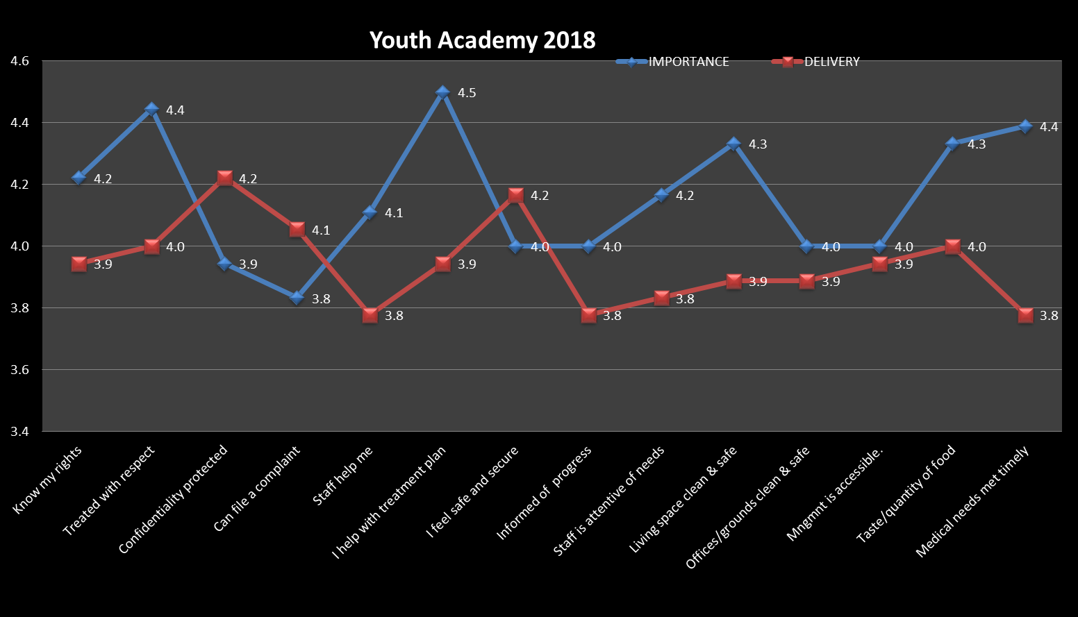
Yore Academy – all of the residents also expressed satisfaction with the program. They made several nice comments regarding their staff, cottage cleanliness and the quality of treatment.

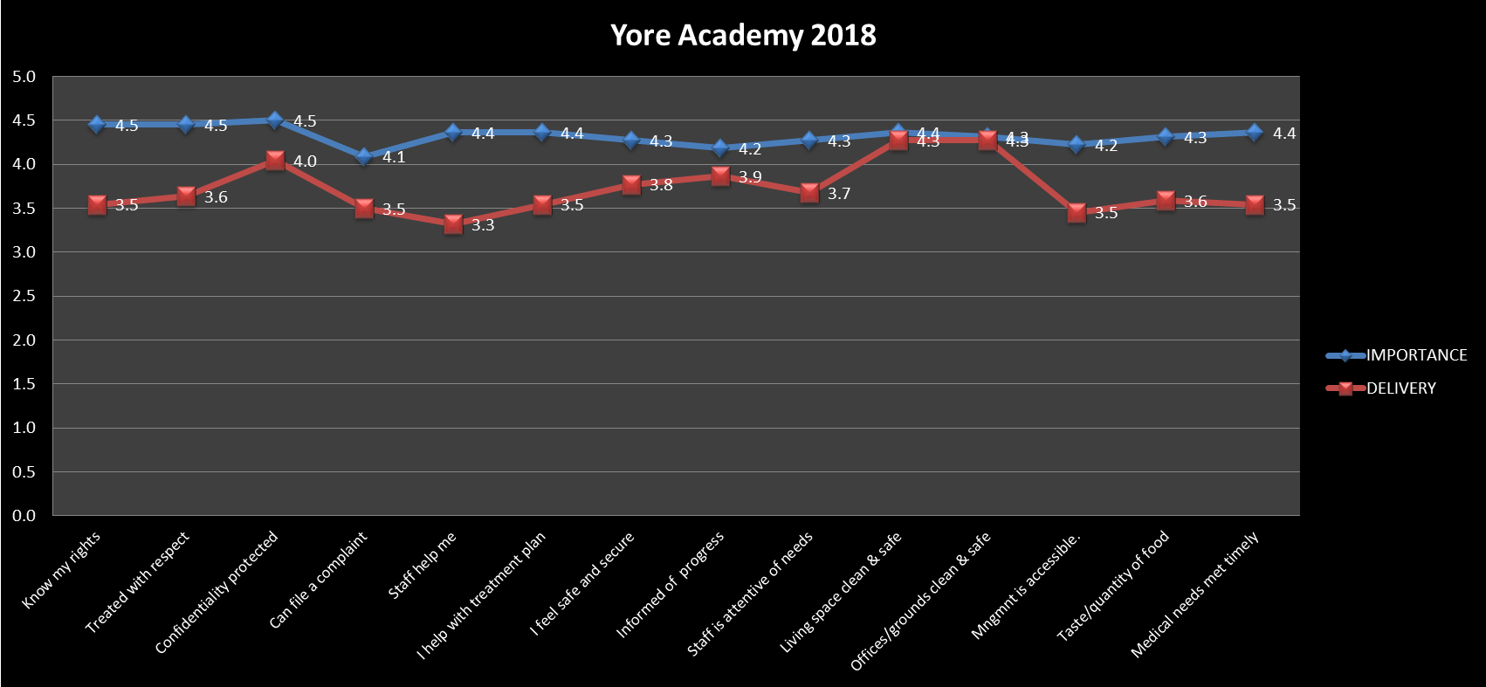
YALE Academy – two opportunities for improvement were noted by residents and steps to make those improvements have been initiated. Residents acknowledged receiving copies of their Resident Rights at intake, as well as having the rights posted in their cottage. Some residents requested a more thorough explanation of those rights. Residents also expressed dissatisfaction at having to wait for an appointment with the physician. They feel that the doctor should see them on the same day they express a medical concern. Discussions regarding when there is a need for emergency care and when there is a need for a scheduled appointment were held with the groups. Since the physician is not an employee of Academy Programs, all appointments are designated by his/her office. The residents now have a better understanding of medical issues. Several compliments regarding the staff and therapists were received.
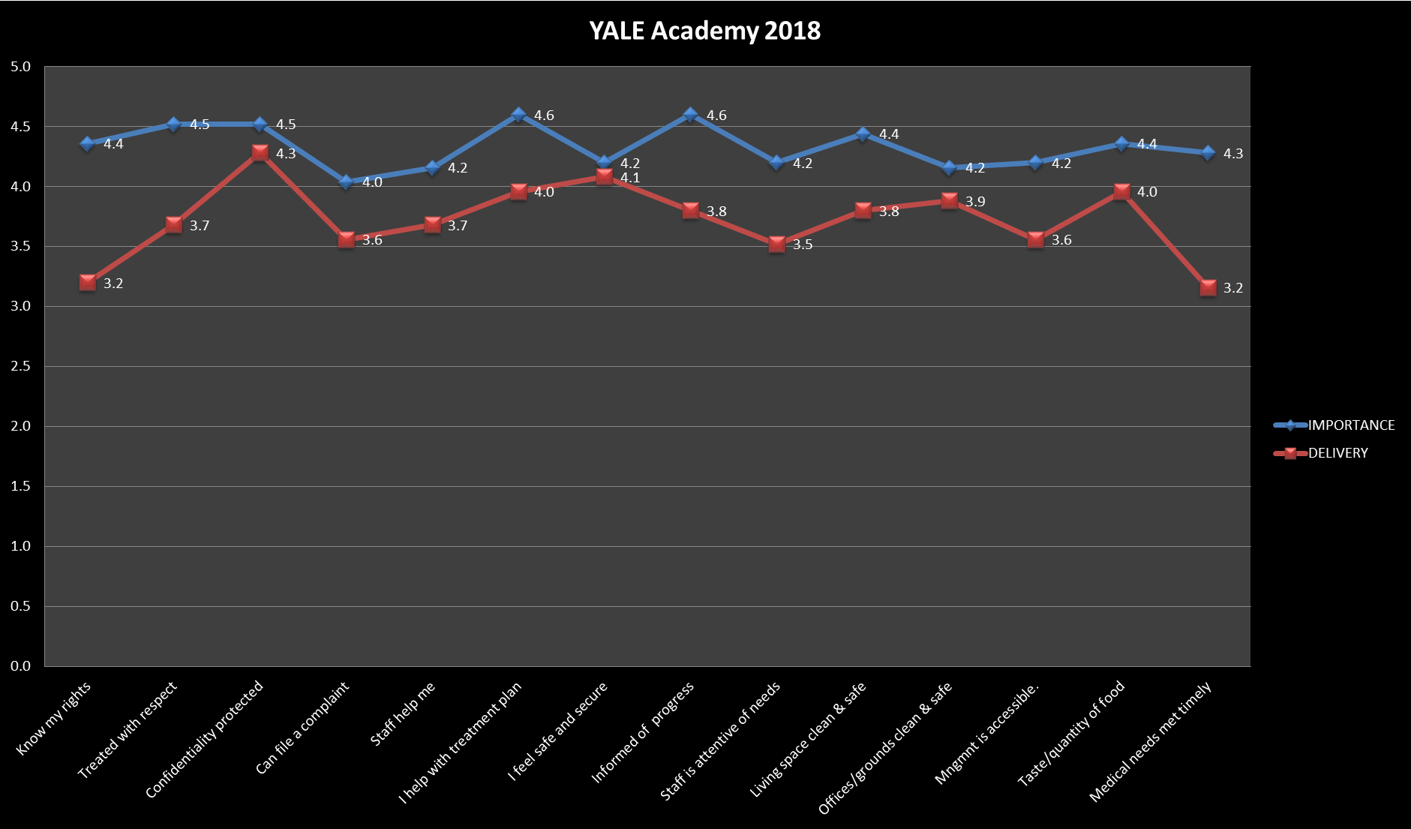

Staff Satisfaction Surveys 2018
Surveys were also distributed to all staff to ascertain their satisfaction with employment at Academy Programs. Opportunities for improvement were noted for three areas – support, training and salary. Comments from staff cited the new scheduling pattern as a positive attribute, made requests for ongoing training and also requests for overtime opportunities. Staff also had several suggestions for ways that they would feel more positive support.

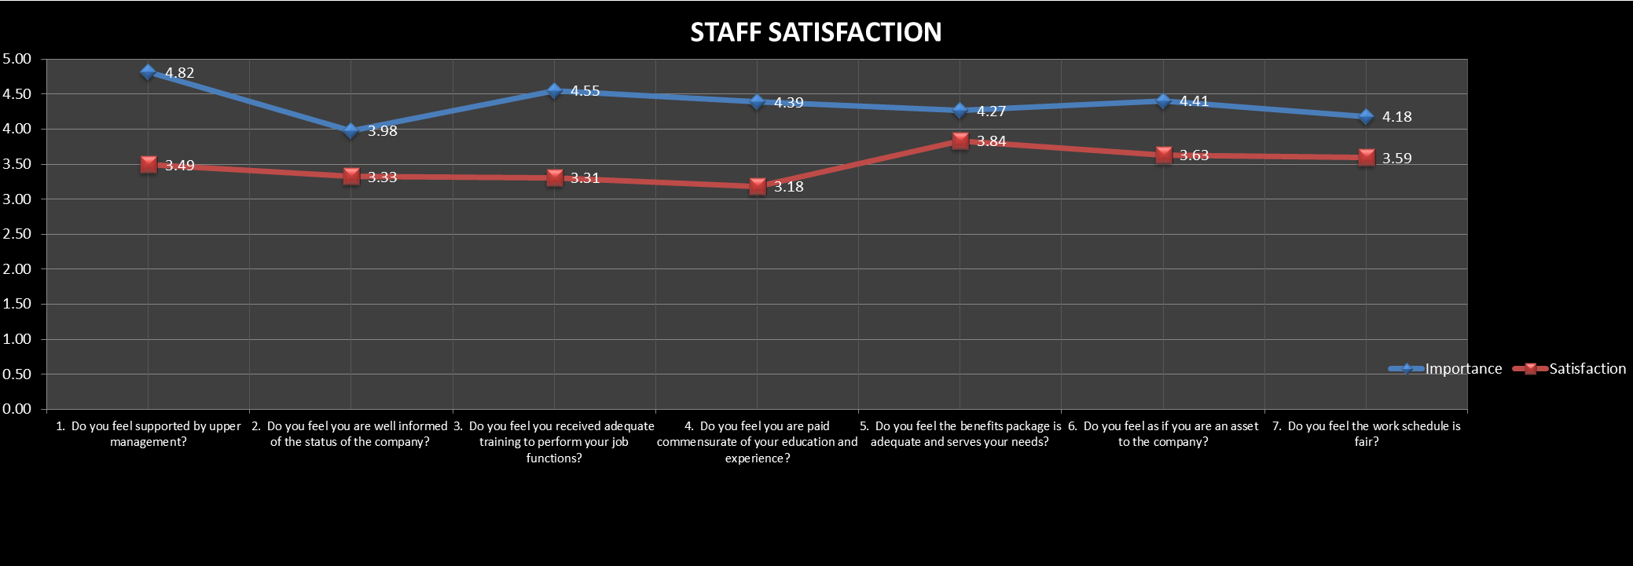

General Staffing Patterns and Staff Turnover
At present, staff are divided into three separate categories: direct care, adjunct/support, and administrative. Direct-care positions include those of Teacher/Counselor, Team Leader, and Case Manager. Teacher/Counselors are also differentiated by degree and/or non-degree status. Teacher/Counselor II requires a degree in a Human Service field as designated by the state licensing body. Teacher/Counselor I require a four-year degree in multiple disciplines, again, as determined by the state licensing body. Assistant Teacher/Counselors are non-degreed, or paraprofessional, staff that support the work of the Teacher/Counselor I and II. Team Leaders are required to have a pre-determined amount of experience in residential services to children and may or may not possess a higher degree as appropriate based on their collective experience. Case Managers are required to possess a degree in a Human Service field as determined by the state licensing body.
At present, 100 percent of the employees holding each of these positions possesses these minimum requirements. Skills for each position are identified and assessed through Staff Benchmarking Protocols, reviewed during individual supervision with their assigned supervisor, and included in Employee Performance Evaluations.
Adjunct and Support positions covers a wide range of responsibilities ranging from clinical personnel, service personnel, medical personnel, Night Watch and clerical personnel. Clinical staff, primarily Therapists, are required to have a Master’s level degree in either Counseling or Social Work. All other positions require a High School diploma, with possible experience relevant to the position. For example, employees in maintenance positions are expected to possess relevant physical plant maintenance experience. Currently, 100 percent of the employees holding all Adjunct and Support positions meet the minimum requirements for their position and skills are assessed through individual supervision conducted each month by their assigned supervisor.
Administrative staff include Program Directors and members of the Management Team. These positions encompass the Executive Director and the Directors of Operations, Finance, Quality Assurance, Admissions, Public Relations, and Treatment, as well as the Deputy Director of Operations. Each of these positions require extensive experience in their field of endeavor, degree and certification requirements as determined by the state licensing body, and a skill set specific to their job duties. Currently 100 percent of the employees holding these positions meet the minimum requirements for that position and skills are assessed through individual supervision with the Executive Director or Director of Operations.
Over the course of the past three years, there has been no turnover in the administrative staff. The Director of Treatment and Deputy Director of Operations positions have been added during this time, and candidates were selected from within the organization. Turnover rate among Adjunct and Support Positions have varied according to department. The organization has experienced no turnover in the medical and clerical departments during the past three years while service personnel have experienced a turnover rate of 50 percent. Night Watch staff have experienced the highest turnover rate with 74 percent and clinical personnel have had a turnover rate of 34 percent. Turnover in direct-care positions has ranged from a low of 23 percent to a high of 31 percent.
At present, 100 percent of the employees possess the education and skills required for their position as mandated by the state licensing body and/or internal policy. Performance review results are addressed at least one time monthly during individual supervision with assigned supervisors and data is collected through the Staff Benchmarking Program. This information is collected and analyzed by the Administrative Coordinator, who produces reports for supervisors and administrators quarterly. This information is used to target training and supervision needs for staff as well as incorporated into annual Program Development Plans.
The organization has not had to focus on recruiting staff that are culturally and ethnically representative of the service population. With the population of West Virginia remaining 94.4 percent Caucasian, 3.7 percent African American, and less than one percent of other ethnicities, the ratio of cultural and ethnic diversity has always been well above the state percentage and the residential population of the facility.
Employee termination and separation data are collected by Human Resources through Exit Interview protocols. This data is reviewed by administrative staff upon completion and incorporated into the Annual Report. The trends associated with the review of this data suggest that Academy Programs is not competing with like companies to retain employees, but rather with other industries that provide the same or higher salaries and do not include the schedule requirements or level of tension and stress that is commonly associated with this industry.

Evaluation of Future Needs
The Academy hired a total of 24 new employees in 2018. Seventy one percent of those employees were hired into direct-care positions. As a result, the Academy will continue to focus on recruiting direct-care positions throughout the course of the coming year. At the time of this report, the Academy has 14 vacant positions with 92 percent of those vacancies occurring in the direct-care ranks. Given that the turnover rate is extremely low in leadership and management positions, combined with the Academy’s commitment to promote from within its ranks, all recruiting efforts will remain focused on filling the direct-care positions.
Recruiting and staffing does not create a particular budgeting concern for the Academy as budgets are created based on a full staffing pattern. Given the Academy’s commitment to promote from within and our commitment to our treatment philosophy, we “strive to be able to use staff with maximum flexibility; thus, Teacher/Counselors, Liaisons, and administrators should be interchangeable, having the same professional preparations.” (Hobbs, 1982, p. 88) This allows the staff of the Academy to cover gaps in the management of logistics where one employee can potentially cover the responsibilities of two to three positions should the need arise. The Academy maintains a ratio of supervisors to employees consistent with the regulations set forth by the state licensing body. Additionally, given our work with people, changes to technology rarely becomes a concern for Academy operations.

Identifying and Closing Gaps
As state previously, the primary position of concern for recruitment and retention remains with the direct-care position, Teacher/Counselor. As such, the majority of our recruiting and retention efforts will remain focused on this position. Recruiting for this position will continue in perpetuity, even should the organization find itself operating with a full staffing pattern. Growth and demand in the need for services will dictate a continued need to recruit, train, and retain employees for this position.
Although the organization has recently added recruiting incentives, including higher salaries and additional performance and longevity bonuses, it is too early for data to be reliably evaluated to determine their effectiveness in recruiting and retention. This data will be closely monitored and evaluated as it becomes sufficient enough to contain a fair degree of reliability.

Community and Family Intensive Treatment
The Youth Academy provides accountable, effective, family-centered, community-based services which are delivered in the least restrictive and most efficient manner. The ultimate objective of the CFIT services program is to maintain youth who are at risk of removal from their biological home or alternative family living arrangement in their home setting. Services may also be provided to transition a youth being placed back into their home from out-of-home placement. CFIT services are designed to preserve whatever family unit the referred child is in as an alternative to repetitive placements or more restrictive placements. The majority of referrals received were for Comprehensive Planning and Assessment Services (CAPS), while the remainder was parenting. In 2018, CFIT received referrals and provided services in Harrison County.

Revenue & Expenditures
2018 Expenditures % of Expense_______
Administrative & Management 7%
Treatment & Program Services 93%
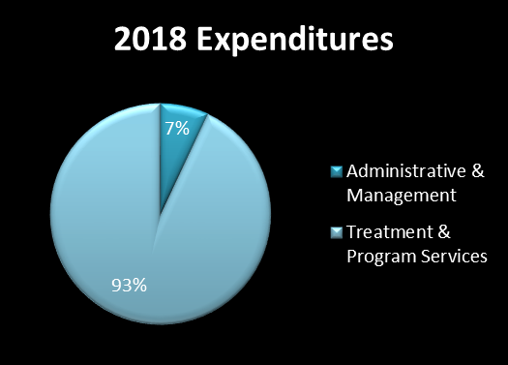

YOUTH ACADEMY
________________Sources of Revenue_______________% of Revenue____Dollar Amount_
WVDHHR 63.5% $1,317,986.79
WV Medicaid 36% $749,570.42
CFIT 0.5% $5,645.34
Total: $2,073,202.55
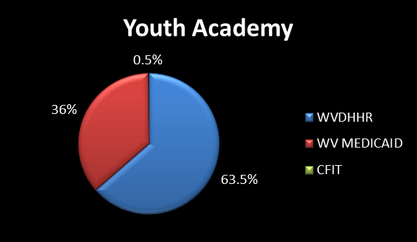

YORE ACADEMY
________________Sources of Revenue_______________% of Revenue____Dollar Amount_
WVDHHR 69% $1,798,005.76
WV Medicaid 31% $806,374.41
Total: $2,604,380.17
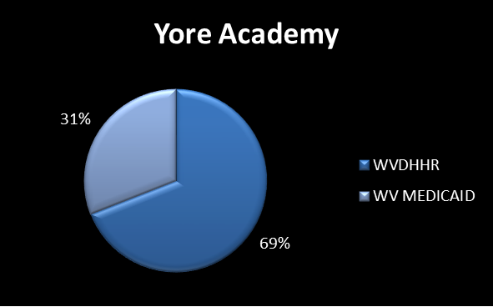

YALE ACADEMY
________________Sources of Revenue_______________% of Revenue____Dollar Amount_
WVDHHR 69% $1,856,681.94
WV Medicaid 31% $819,441.85
Total: $2,676,123.79
